Chapter 6

Jointly Distributed Random Variables

  - Joint Distribution Functions
- Motivation ---
  - Sometimes we are interested in probability statements concerning two or more random variables whose outcomes are related. Such random variables are said to be jointly distributed.
  - In this chapter, we make discussions about the pdf, cdf, and related facts and theorems about various jointly distributed random variables.

- The cdf and pdf of two jointly distributed random variables ---
  - Definition 6.1 (joint cdf)---
The joint cdf of two random variables X and Y is defined as
F_{XY}(a, b) = P{X ≤ a, Y ≤ b} ∀ ∞ < a, b < ∞.
  - Note: F_{XY}(∞, ∞) = 1.

  - Definition 6.2 (marginal cdf) ---
The marginal cdf (or simply marginal distribution) of the random variable X can be obtained from the joint cdf F_{XY}(a, b) of two random variables X and Y as follows:
F_{X}(a) = P{X ≤ a}
= P{X ≤ a, Y < ∞}
= P(lim_{b→ ∞}{X ≤ a, Y ≤ b})
= lim_{b→ ∞}P{X ≤ a, Y ≤ b}
= lim_{b→ ∞}F_{XY}(a, b)
≡ F_{XY} (a, ∞).
The marginal cdf of random variable Y may be obtained similarly as
F_{Y}(b) = P{Y ≤ b}
= lim_{a→ ∞}F_{XY}(a, b)
= F_{XY}(∞, b).

- Facts about joint probability statements ---
  - All joint probability statements about X and Y can be answered in terms of their joint distribution.

  - Fact 6.1 ---
P{X > a, Y > b} = 1 − F_{X}(a) − F_{Y}(b) + F_{XY}(a, b). (6.1)
Proof:
P{X > a, Y > b} = 1 − P({X > a, Y > b}^{C})
= 1 − P({X > a}^{C} U {Y > b}^{C})
= 1 − P({X ≤ a} U {Y ≤ b})
= 1 − [P{X ≤ a} + P{Y ≤ b} − P{X ≤ a, Y ≤ b}]
= 1 − F_{X}(a) − F_{Y}(b) + F_{XY}(a, b).
  - The above fact is a special case of the following one.

  - Fact 6.2 ---
P{a₁ < X ≤ a₂, b₁ < Y ≤ b₂} = F_{XY}(a₂, b₂) − F_{XY}(a₁, b₂) − F_{XY}(a₂, b₁) + F_{XY}(a₁, b₁)
(6.2)
where a₁ < a₂ and b₁ < b₂.
Proof: left as an exercise (note: taking both a₂ = ∞, b₂ = ∞ and a₁ = a, b₁ = b in (6.2) leads to (6.1))

- The pmf of two discrete random variables ---
  - Definition 6.3 (joint pmf of two discrete random variables) ---
The joint pmf of two discrete random variables X and Y is defined as
p_{XY}(x, y) = P{X = x, Y = y}.

  - Definition 6.4 (marginal pmf) ---
The marginal pmfs of X and Y are defined respectively as
p_{X}(x) = P{X = x} = 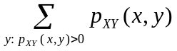;
p_{Y}(y) = P{Y = y} = 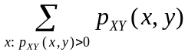.

- Example 6.1 ---
Suppose that 15% of the families in a certain community have no children, 20% have 1, 35% have 2, 30% have 3; and suppose further that each child in a family is equally likely to be a girl or a boy. If a family is chosen randomly from the community, what is the joint pmf of the number B of boys and the number G of girls, both being random in nature, in the family?
Solution:
P{B = 0, G = 0} = P{no children} = 0.15;
P{B = 0, G = 1} = P{1 girl and a total of 1 child}
= P{1 child}×P{1 girl|1 child}
= 0.20×0.50
= 0.1;
P{B = 0, G = 2} = P{2 girl and a total of 2 children}
= P{2 children}×P{2 girls|2 children}
= 0.35×(0.50)²
= 0.0875,
and so on (derive the other probabilities by yourself).

- Joint continuous random variables ---
  - Definition 6.5 (joint continuous random variables) ---
Two random variables X and Y are said to be jointly continuous if there exits a function f_{XY}(x, y) which has the property that for every set C of pairs of real numbers, the following is true:
P{(X, Y) ∈ C} = 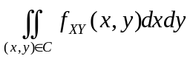 (6.3)
where the function f_{XY}(x, y) is called the joint pdf of X and Y.

  - Fact 6.3 ---
If C = {(x, y) | x ∈ A, y ∈ B}, then
P{X ∈ A, Y ∈ B} = 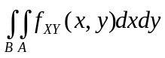. (6.4)
Proof: immediately from (6.3) of Definition 6.5.

  - Fact 6.4 ---
The joint pdf f_{XY}(x, y) may be obtained from the cdf F_{XY}(x, y) in the following way:
f_{XY}(a, b) = 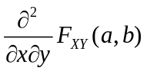.
Proof: immediate from the following equality derived from the definition of the cdf
F_{XY}(a, b) = P{X ∈ (−∞, a], Y ∈ (−∞, b]} = 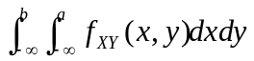.

  - Fact 6.5 ---
The marginal pdf’s for jointly distributed random variables X and Y is respectively
f_{X}(x) = 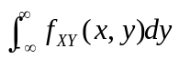;
f_{Y}(y) = 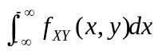,
which means the two random variables are individually continuous.
Proof:
    - If X and Y are jointly continuous, then
P{X ∈ A} = P{X ∈ A, Y ∈ (−∞, ∞)} = 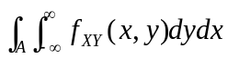.
    - On the other hand, by definition we have
P{X ∈ A} = 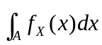.
    - So the marginal pdf for random variable X is
f_{X}(x) = .
    - Similarly, the marginal pdf of Y may be derived to be
f_{Y}(y) = .

  - Joint pdf for more than two random variables --- can be similarly defined; see the reference book for the details.

- Example 6.2 ---
The joint pdf of random variables X and Y is given by
f_{XY}(x, y) = 2e^{−x}e^{−2y} ∀ 0 < X < ∞, 0 < Y < ∞;
= 0, otherwise.
Compute (a) P{X > 1, Y < 1}and (b) P{X < Y}.
Solution for (a):
P{X > 1, Y < 1} = 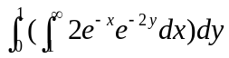
= 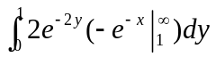
= e⁻¹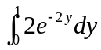
= e⁻¹(1 − e⁻²).
Solution for (b):
According to Fig. 1 which shows the area of integration with property of x < y (the shaded portion), we have
P{X < Y} = 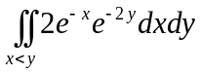
= 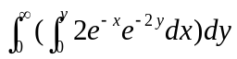
= 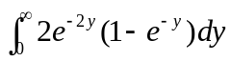
= 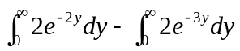
= 1 − 2/3
= 1/3.

x = y
x < y
Fig. 1 Shaded area with property x < y for computing P{X < Y} in Example 6.2.

- The cdf and pdf of more than two jointly distributed random variables ---
  - Definition 6.6 ---
The joint cdf of n random variables X₁, X₂, …, X_{n} is defined as
F_{X1X2}…_{Xn}(a₁, a₂, …, a_{n}) = P{X₁ ≤ a₁, X₂ ≤ a₂, …, X_{n} ≤ a_{n}}.

  - Definition 6.7 ---
A set of n random variables are said to be jointly continuous if there exists a function f_{X1X2…Xn}(x₁, x₂, …, x_{n}), called the joint pdf, such that for any set C in n-space, the following equality is true:
P{(X₁, X₂, …, X_{n}) ∈ C} = 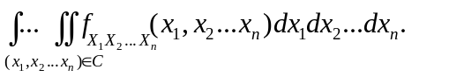
(Note: n-space is the set of n-tuples of real numbers.)

  - Definition 6.8 (multinomial distribution -- a generalization of binomial distribution) ---
In n independent trials, each with r possible outcomes with respective probabilities p₁, p₂, …, p_{r} where 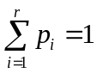, if X₁, X₂, …, X_{r} represent respectively the numbers of the r outcomes, then these r random variables are said to have a multinomial distribution with parameters (n; p₁, p₂, …, p_{r}).

  - Fact 6.6 ---
Multinomial random variables X₁, X₂, …, X_{r} with parameters (n; p₁, p₂, …, p_{r}) and 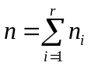 has the following joint pmf
f_{X1X2…Xn}(n₁, n₂, …, n_{r}) = P{X₁ = n₁, X₂ = n₂, …, X_{r} = n_{r}}
= C(n; n₁, n₂, …, n_{r})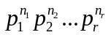
= 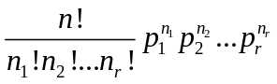.
Proof: use reasoning similar to that for proving pmf for the binomial random variable (Fact 4.6 and Example 3.11); left as an exercise.

- Example 6.3 ---
A fair die is rolled 9 times. What is the probability that 1 appears three times, 2 and 3 twice each, 4 and 5 once each, and 6 not at all?
Solution:
  - Based on Fact 6.6 with n = 9, r = 6, all p_{i} = 1/6 for i = 1, 2, …, 6, and n₁ = 3, n₂ = n₃ = 2, n₄ = n₅ = 1, n₆ = 0, the probability may be computed as
= [9!/(3!2!2!1!1!0!)]×(1/6)³(1/6)²(1/6)²(1/6)¹(1/6)¹(1/6)⁰
= (9!/3!2!2!)×(1/6)⁹ = 15120/10077696 ≈ 0.0015.

  - Independent Random Variables
- Concept ---
Independent jointly distributed random variables have many interesting and “harmonic” properties worth investigation and useful for many applications.

- Definitions and properties ---
  - Definition 6.9 (independence and dependence of two random variables) ---
Two random variables X and Y are said to be independent if for any two sets A and B of real numbers, the following equality is true:
P{X ∈ A, Y ∈ B}= P{X ∈ A}×P{Y ∈ B}. (6.5)
Random variables that are not independent are said to be dependent.

  - The above definition says that X and Y are independent if, for all A and B, the two events E_{A} = {X ∈ A} and F_{B} = {X ∈ B} are independent.

  - Fact 6.7 ---
Random variables X and Y are independent if and only if, for all a and b, either of the following two equalities is true:
P{X ≤ a, Y ≤ b}= P{X ≤ a}×P{Y ≤ b}; (6.6)
F_{XY}(a, b) = F_{X}(a)×F_{Y}(b). (6.7)
Proof: can be done by using the three axioms of probability and (6.5) above; left as an exercise.

  - Fact 6.8 ---
Discrete random variables X and Y are independent if and only if, for all a and b, the following equality about pmf’s is true:
p_{XY}(x, y) = p_{X}(x)×p_{Y}(y). (6.8)
Proof:
    - (Proof of “only-if” part) if (6.5) is true, then (6.8) can obtained by letting A and B to be the one-point sets A = {x} and B = {y}, respectively.
    - (Proof of “if” part) if (6.8) is true, then for any sets A and B, we have
P{X ∈ A, Y ∈ B} = 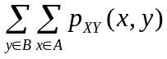
= 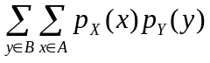
= 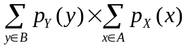
= P{X ∈ A}×P{Y ∈ B}.
    - From the above two parts, the fact is proved.

  - Fact 6.9 ---
Continuous random variables X and Y are independent if and only if, for all a and b, the following equality about pdf’s is true:
f_{XY}(x, y) = f_{X}(x)×f_{Y}(y). (6.9)
Proof: similar to the proof for the last fact; left as an exercise.

  - Thus, we have four ways (probability, cdf, pmf, and pdf) for testing the independence of two random variables in addition to the definition.
  - For the definition of independence of more than two random variables, see the reference book.

- Example 6.4 ---
A man and a woman decide to meet at a certain location. If each person independently arrives at a time uniformly distributed between 12 noon and 1 pm, find the probability that the first to arrive has to wait longer than 10 minutes.
Solution:
  - Let random variables X and Y denote respectively the time past 12 that the man and woman arrive.
  - Then, X and Y are uniformly distributed over (0, 60) as said in the problem description.
  - The desired probability is P{X + 10 < Y} + P{Y + 10 < X}.
  - By symmetry, P{X + 10 < Y} + P{Y + 10 < X} = 2P{X + 10 < Y}.
  - Finally, according to Fig. 6.2 we get
2P{X + 10 < Y} = 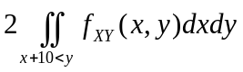
= 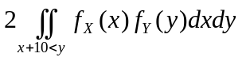
=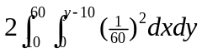
= 25/36.

60
10
x+10 = y

Fig. 6.2 Shaded area with property x + 10 < y for computing 2P{X + 10 < Y} in Example 6.4.

- Proposition 6.1 ---
Two continuous (discrete) random variables X and Y are independent iff their joint pdf (pmf) can be expressed as
f_{XY}(x, y) = h_{X}(x)g_{Y}(y) ∀ −∞ <x < ∞, −∞ < y < ∞,
where h_{X} (x) and g_{Y}(y) are two functions of x and y, respectively; that is, iff f_{XY}(x, y) factors (會因式分解) into f_{X}(x) and g_{Y}(y). (Note: iff means if and only if.)
Proof: see the reference book.

- Example 6.5 ---
If the joint pdf of X and Y is
f_{XY}(x, y) = 6e^{−2x}e^{−3y} ∀ 0 < x < ∞, 0 <y < ∞;
= 0 otherwise.
Are the random variables independent? What if the pdf is as follows?
f_{XY}(x, y) = 24xy ∀ 0 < x < 1, 0 <y < 1, 0 < x + y < 1;
= 0 otherwise.
Solution:
  - The answer to the first case is yes because f_{XY} factors into g_{X}(x) = 2e^{−2x} ∀ 0 < x < ∞, and h_{Y}(y) = 3e^{−3y} ∀ 0 <y < ∞.
  - The answer to the second case is no because the region in which the pdf is nonzero cannot be expressed in the form x ∈ A and y ∈ B.

  - More of Continuous Random Variables
- Gamma random variable ----
  - Definition 6.7 (gamma random variable) ---
A random variable is said to have a gamma distribution with parameters (t, λ) where t > 0 and λ > 0 if its pdf is given by
f(x) = λe^{−λx}(λx)^{t−1}/Γ(t) ∀ x ≥ 0;
= 0 ∀ x < 0,
where Γ(t), called the gamma function, is defined as
Γ(t) = 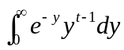.

  - Fact 6.10 (properties of the gamma function) ---
It can be shown that the following equalities are true:
Γ(t) = (t − 1)Γ(t − 1);
Γ(n) = (n − 1)!;
Γ(1/2) = 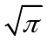.
Proof: left as exercises or see the reference book.

  - Curves of the pdf of the gamma distribution ---
A family of the curves of the pdf of a gamma random variable is shown in Fig. 6.3. Note the leaning phenomenon of the curves to the left side.

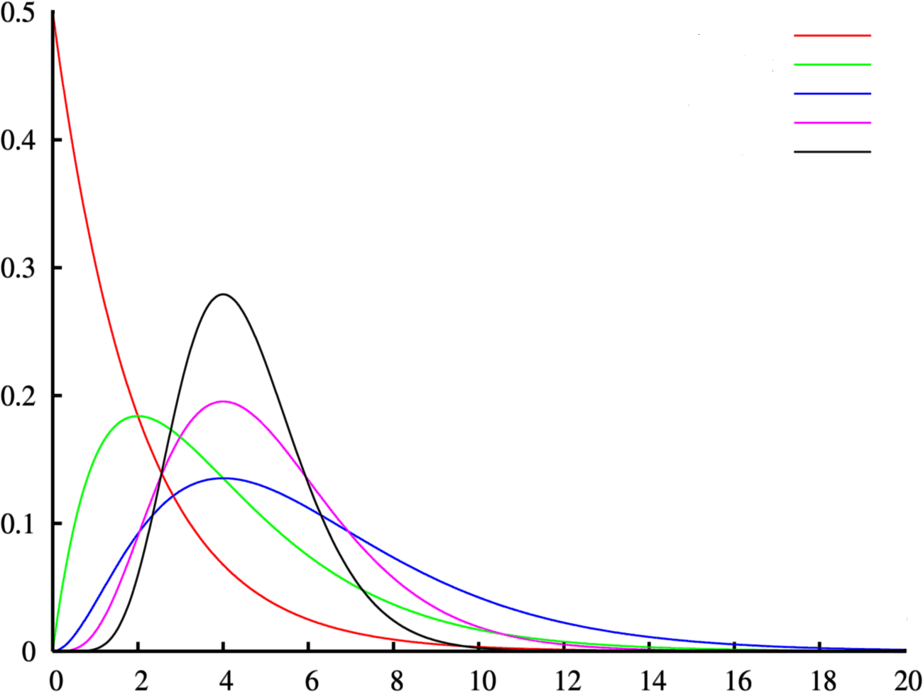
t = 1, λ = 0.5
t = 2, λ = 0.5
t = 3, λ = 0.5
t = 5, λ = 1.0
t = 9, λ = 2.0

Fig. 6.3 A family of pdf curves of a gamma random variable.

  - Fact 6.11 (the cdf of a gamma random variable) ---
The cdf of a gamma random variable X with parameters (t, λ) is given by
F(a) = P{X ≤ a} = 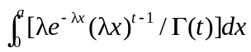
= 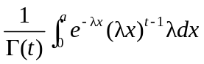
= 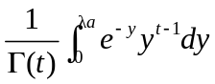. (let y = λx so that dy = λdx)

- Incomplete gamma function ---
  - Definition 6.8 (incomplete gamma function) ---
The incomplete gamma function γ with parameters (x, t) is defined as
γ(x; t) = 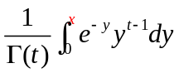. (6.10)
(cf., the gamma function is Γ(t) = 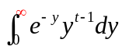.)
(Note: “cf.” is an abbreviation for the Latin word confer, meaning “compare” or “consult.”)

  - Computing the values of the incomplete gamma function ---
The values of the incomplete gamma function are usually listed as a table. Its values may be computed by the following free online calculator:
http://www.danielsoper.com/statcalc/calc33.aspx
(with a and t at the site there regarded as t and x respectively here in (6.10) above). a =15, t =14

  - Fact 6.12 ---
The relation between the incomplete gamma function γ(a; t) and the cdf F(a) of the gamma distribution may be described by
F(a) = = γ(λa; t).

  - Fact 6.13 (the mean and variance of the gamma distribution) ---
The mean and variance of a gamma random variable X are
E[X] = t/λ;
Var(X) = t/λ².
Proof: left as exercises or see the reference book.

- Poisson event and n-Erlang distribution ---
  - Definition 6.9 (Poisson event) ---
An event which occurs in accordance with the Poisson Process is called a Poisson event, which is associated with a rate λ specifying the frequency of the occurrence of the event in a time unit.

  - Definition 6.10 (n-Erlang distribution) ---
A gamma distribution with parameters (t, λ) and t being an integer n is called an n-Erlang distribution with parameter λ, which has the following pdf:
f(x) = 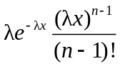 ∀ x ≥ 0;
= 0 ∀ x < 0,
(because Γ(t) in Definition 6.7 is Γ(t) = Γ(n) = (n − 1)! here, according to Fact 6.10) and the following cdf:
F(x) = 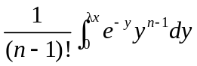 = γ(λx; n)
(according to Fact 6.12) where γ(λx; n) is the incomplete gamma distribution (see Definition 6.8).

  - A historical note ---
Agner Krarup Erlang (January 1, 1878 – February 3, 1929) was a Danish mathematician, statistician and engineer, who invented the fields of traffic engineering and queueing theory, leading to present-day studies of telecommunication networks.

  - Usefulness of the n-Erlang distribution ---
    - The Erlang distribution plays a key role in the queueing theory.
    - Queueing theory is the study of waiting lines, called queues, which analyzes several related processes, including arriving at the (back of the) queue, waiting in the queue (essentially a storage process), and being served by the server(s) at the front of the queue.

  - Fact 6.14 (use of n-Erlang distribution) ---
The amount of time one has to wait until a total of n Poisson events with rate λ has occurred is an n-Erlang distribution with parameter λ whose pdf is f(x) = λe^{−λx}(λx)^{n−1}/(n − 1)! ∀ x ≥ 0; and 0, otherwise.
Proof:
    - Recall Fact 5.9 that a Poisson random variable N(t) with parameter λt and pmf described as follows can be used to specify the number of events occurring in a fixed time interval of length t:
P{N(t) = i} = 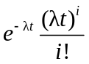 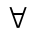i =1, 2, ...
    - Let the time starting from now until a total of n Poisson events with rate λ has occurred be denoted as a random variable X_{n}.
    - Note that X_{n} is smaller than t iff the number N(t) of Poisson events occurring in the time interval of [0, t] is at least n.
    - That is, the cdf of X_{n} is:
P{X_{n} ≤ t} = P{N(t) ≥ n}
= 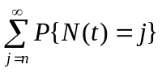
= 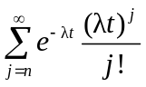 ∀ t ≥ 0;
= 0 otherwise.
    - Therefore, the pdf f(t) of X_{n}, which is the differentiation of the above with respect to t, equals
f(t) = 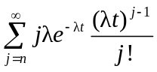 + 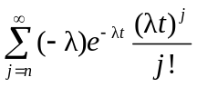
= 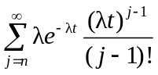 − 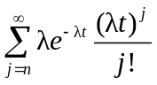
= 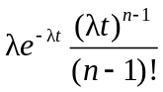 + 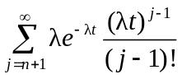 −
= ∀ t ≥ 0;
= 0 otherwise.
which is exactly the pdf f(x) with x = t of an n-Erlang distribution with parameter λ. Done.

  - A note: in the above fact, to compute the probability P{X_{n} ≤ t}, in practice rather than using the term derived above, the cdf of the n-Erlang distribution described in Definition 6.10 is used:
F(t) = 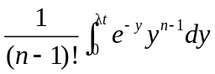 = γ(λt; n).

- Recall of usefulness of the exponential distribution ---
  - The exponential distribution often arises, in practice, as being the distribution of the amount of time until some specific event occurs (Fact 5.11 in Chapter 5).
  - This is just a special case of the gamma (or n-Erlang) distribution as described by Fact 6.15 below.

- Relations between the gamma distribution and the exponential distribution ---
  - Fact 6.15 (reduction of an n-Erlang distribution to an exponential distribution) ---
An n-Erlang random variable with parameter λ reduces to an exponential distribution with parameter λ when n = 1.
Proof:
It is easy to see this fact from the following pdf of an n-Erlang random variable with parameter :
f(x) = ∀ x ≥ 0;
= 0 ∀ x < 0
which reduces to the following pdf of an exponential random variable when n = 1:
f(x) = λe^{−λx} if x ≥ 0;
= 0 if x < 0
because (n − 1)! = (1 − 1)! = 0! = 1 according to Fact 6.10 and (λx)^{n−1} = (λx)¹⁻¹ = (λx)⁰ = 1.

- A summary of uses of Poisson, exponential, and gamma (n-Erlang) distributions ---
  - Poisson distribution (Fact 4.8) --- may be used to specify
“the number X of successes occurring in n independent trials, each of which has a success probability p, where n is large and p is small enough to make np moderate”
in the following way:
P{X = i} ≈ 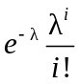 i =1, 2, ...
where the parameter λ of X is computed as λ = np.

  - Poisson distribution (Fact 5.9) --- may also be used to specify
“the number N of Poisson events with rate λ occurring in a fixed time interval of length t”
in the following way:
P{N(t) = i} = i =1, 2, ...

  - Exponential distribution (Fact 5.11) --- may be used to specify
“the amount X of time one has to wait from now until a Poisson event with rate λ has occurred”
in the following way:
F(t) = P{X ≤ t} = 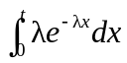
= 1 − e^{−λt} ∀ t ≥ 0;
= 0 otherwise.
where F is the cdf of X (the corresponding pdf is f(x) = λe^{−λx} ∀ x ≥ 0; 0, otherwise).

  - Gamma (n-Erlang) distribution (Fact 6.14) --- specifying
“the amount of time one has to wait until a total of n Poisson events with rate λ has occurred”
in the following way:
F(t) = P{X_{n} ≤ t} =
= γ(λt; n) ∀ t ≥ 0;
= 0 otherwise,
where γ(λt; n) is the incomplete gamma function with parameters (λt, n).

- Example 6.6 (use of the gamma (n-Erlang) distribution; extension of Example 5.9) ---

Assume that earthquakes occur in the western part of the US as Poisson events with rate λ = 2 per week. Find the probability that the time starting from now until 5 earthquakes have occurred is not greater than 4 weeks.
Solution:
  - According to Fact 6.14, the time may be described by a random variable X₅ with a 5-Erlang distribution with parameter λ = 2 so that the desired probability is
P{X₅ ≤ 4} = γ(λt; n) = γ(2×4; 5) = γ(8, 5) ≈ 0.90
where the value γ(8, 5) is computed at the website suggested previously.

- Chi-square distribution ---
  - Definition 6.11 (chi-square distribution) ---
The gamma distribution with parameters λ = 1/2 and t = n/2 (n being a positive integer) is called the χ² (read as /kai skwεr/) or chi-square distribution with n degrees of freedom. That is, a random variable with the χ² distribution with n degrees of freedom has the following pdf:
f(x) = (1/2)^{n/2}e^{−x/2}x^{(n/2)−1}/Γ(n/2) ∀ x ≥ 0;
= 0 otherwise.

  - Fact 6.16 (relation between the unit normal and gamma random variables) ---
If Z is a unit normal random variable, then the square of it, Y = Z², is just a gamma random variable with parameters (1/2, 1/2).
Proof:
    - From Example 5.12, we know Y = X² has a pdf of the following form:
f_{Y}(y) = 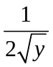[f_{X}(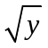) + f_{X}(−)] ∀ y ≥ 0;
= 0 otherwise,
where f_{X}(y) is the pdf of random variable X.
    - Take X to be the unit normal random variable Z which has a pdf of the following form:
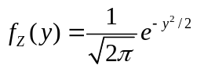.
    - Then, the desired pdf above becomes
f_{Y}(y) = [f_{Z}() + f_{Z}(−)]
= [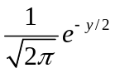 + ]
= 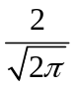e^{−y/2}
= y^{−(1/2)}2^{−(1/2)}e^{−(1/2)y}/
= (1/2)e^{−(1/2)y}[(1/2)y]^{(1/2)−1}/Γ(1/2)
which can be seen to be of the pdf form of a gamma random variable:
f(x) = λe^{−λx}(λx)^{t−1}/Γ(t) ∀ x ≥ 0;
= 0 otherwise
with parameters (t = 1/2, λ = 1/2) because Γ(1/2) = according to Fact 6.10.

  - Sum of Independent Random Variables
- Motivation ---
It is often required to compute the cdf, pdf, and other properties of the sum X + Y of two independent random variables X and Y.

- Joint cdf and pdf of independent random variables ---
  - Fact 6.17 ---
Let X and Y be continuous and independent with pdf f_{X} and f_{Y}, respectively. Then, the cdf of X + Y is
F_{X+Y}(a) = 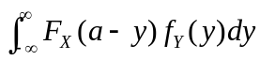. (6.11)
Proof: F_{X+Y}(a) = P{X + Y ≤ a}
= 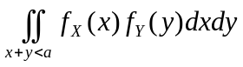
= 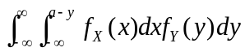
= .

  - The cdf derived above is called the convolution of the cdf’s of X and Y, which is used in many applications, including statistics, computer vision, image and signal processing, electrical engineering, and differential equations.

  - Fact 6.18 ---
The pdf of X + Y is f_{X+Y}(a) = 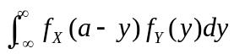. (6.12)
Proof: By differentiating the cdf obtained previously, the pdf of X + Y can be obtained as follows:
f_{X+Y}(a) = 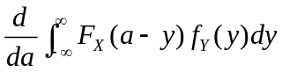
= 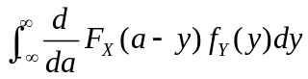
= .

- Example 6.7 (sum of two independent uniform random variables) ---
If X and Y are two independent random variables both uniformly distributed on (0, 1), find the pdf of X + Y.
Solution:
  - f_{X}(a) = f_{Y}(a) = 1 if 0 < a < 1;
= 0, otherwise.
  - From Fact 6.18, we get
f_{X+Y}(a) = 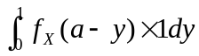
= 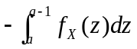 = 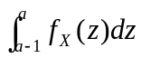.
  - If 0 ≤ a ≤ 1, then 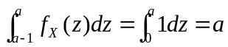;
If 1 < a ≤ 2, then 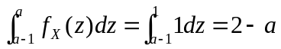.
  - So f_{X+Y}(a) = a ∀ 0 ≤ a ≤ 1;
= 2 − a ∀ 1 < a ≤ 2;
= 0 otherwise.

- Some facts about the summation of two independent random variables ----
  - About two independent random variables X and Y, we have the following facts. See the reference book for the proof of each of them.

  - Fact 6.19 ---
If X and Y are two independent gamma random variables with respective parameters (s, λ) and (t, λ), then X + Y is also a gamma random variable with parameters (s + t, λ).

  - Fact 6.20 ---
If X and Y are two independent normal random variables with respective parameters (μ_{X}, σ_{X}²) and (μ_{Y}, σ_{y}²), then X + Y is also normally distributed with parameters (μ_{X} + μ_{Y}, σ_{X}² + σ_{Y}²).

  - Fact 6.21 ---
If X and Y are two independent Poisson random variables with respective parameters λ₁ and λ₂, then X + Y is also a Poisson random variable with parameter λ₁ + λ₂.

  - Fact 6.22 ---
If X and Y are two independent binomial random variables with respective parameters (n, p) and (m, p), then X + Y is also a binomial random variable with parameters (n + m, p).

- Composition of independent exponential distributions as a gamma distribution ---
  - Fact 6.23 ---
If X₁, X₂, …, X_{n} are n independent exponential random variables with identical parameter λ, then the sum Y = X₁ + X₂ + ... + X_{n} is a gamma random variable with parameters (n, λ).
Proof: easy by using Fact 6.19; left as an exercise.

- Composition of independent normal distributions as a χ² distribution ---
  - Proposition 6.2 (relation between the sum of unit normal random variable and the χ² distribution) ---
Given n independent unit normal random variables Z₁, Z₂, …, Z_{n}, the sum of their squares, Y = Z₁² + Z₂² + … + Z_{n}², is a random variable with a χ² distribution with n degrees freedom.
Proof: easy by applying Facts 6.16 and 6.19; left as an exercise.

  - Proposition 6.3 (relation between the sum of normal random variable and the χ² distribution) ---
If X₁, X₂, …, X_{n} are n independent normally distributed random variables all with identical parameters (μ, σ²), then the sum
Y = 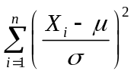
has a χ² distribution with n degrees of freedom.
Proof: easy by applying Fact 5.5 in the last chapter and Proposition 6.2; left as an exercise.

  - Usefulness of the χ² distribution ---
The chi-square distribution often arises in practice as being the distribution of the error involved in attempting to hit a target in n dimensional space when each coordinate error is normally distributed (based on Propositions 6.2 and 6.3).

- Linearity of parameters of the weighted sum of independent normal random variables ----
  - Proposition 6.4 ---
If X₁, X₂, …, X_{n} are n independent normal random variables with parameters (μ_{i}, σ_{i}²), i = 1, 2, …, n, then for any n constants a₁, a₂, …, a_{n}, the linear sum Y = a₁X₁ + a₂X₂ + … + a_{n}X_{n} is a normal random variable with parameters (a₁μ₁ + a₂μ₂ + … + a_{n}μ_{n}, a₁²σ₁² + a₂²σ₂² + … + a_{n}²σ_{n}²), i.e., it has a mean of the following form:
a₁μ₁ + a₂μ₂ + … + a_{n}μ_{n}
and a variance of the following form:
a₁²σ₁² + a₂²σ₂² + … + a_{n}²σ_{n}².
Proof: easy by applying Fact 6.20; left as an exercise.

  - Conditional Distribution --- Discrete Case
- Definitions ---
  - Recall: the conditional probability of event E given event F is defined as P(E|F) = P(EF)/P(F), provided that P(F) > 0.
  - Definition 6.12 ---
The conditional probability mass function (conditional pmf) of a random variable X given that a value of another, Y = y, is defined by
p_{X|Y}(x|y) = P{X = x|Y = y}
= P{X = x, Y = y}/P{Y = y}
= p_{XY}(x, y)/p_{Y}(y)
for all values of y such that p_{Y}(y) > 0.

  - Definition 6.13 ---
The conditional cumulative distribution function (conditional cdf) of random variable X given that a value of another, Y = y, is defined by
F_{X|Y}(x|y) = P{X ≤ x|Y = y}
= 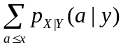
for all values of y such that p_{Y}(y) > 0.

  - Fact 6.24 ---
When X and Y are independent, then we have:
p_{X|Y}(x|y) = P{X = x} = p_{X}(x);
F_{X|Y}(x|y) = P{X ≤ x}= 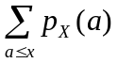.
Proof: left as an exercise.

- Example 6.8 ---
Suppose that joint pmf of random variables X and Y is given by
p_{XY}(0, 0) = 0.4, p_{XY}(0, 1) = 0.2
p_{XY}(1, 0) = 0.1, p_{XY}(1, 1) = 0.3.
Compute the conditional pmf of X, given that Y = 1.
Solution:
  - The marginal pmf p_{Y} (1) = p_{XY}(0, 1) + p_{XY}(1, 1) = 0.2 + 0.3 = 0.5.
  - Desired conditional pmf is:
p_{X|Y}(0|1) = p_{XY}(0, 1)/p_{Y}(1) = 2/5;
p_{X|Y}(1|1) = p_{XY}(1, 1)/p_{Y}(1) = 3/5.

  - Conditional Distribution --- Continuous Case
- More definitions ---
  - Definition 6.14 ---
If random variables X and Y have a joint pdf f_{XY}(x, y), the conditional probability density function (conditional pdf) of random variable X given that Y = y is defined by
f_{X|Y}(x|y) = f_{XY}(x, y)/f_{Y}(y)
for all values of y such that f_{Y}(y) > 0.

  - Definition 6.15 ---
The conditional cumulative distribution function (conditional cdf) of random variable X given that Y = y is defined by
F_{X|Y}(x|y) = P{X ≤ x|Y = y}
= 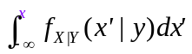.

- Example 6.9 ---
Given the following joint pdf of two random variables X and Y:
f_{XY}(x, y) = 15x(2 − x − y)/2 ∀ 0 < x < 1, 0 < y < 1;
= 0 otherwise,
compute the conditional pdf of X given that Y = y.
Solution:
f_{X|Y}(x|y) = f_{XY}(x, y)/f_{Y}(y)
= f_{XY}(x, y)/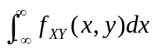
= x(2 − x − y)/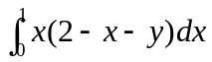
= x(2 − x − y)/(2/3 − y/2)
= 6x(2 − x − y)/(4 − 3y).

  - Fact 6.25 ---
If random variables X and Y are independent, then we have:
f_{X|Y}(x|y) = f_{XY}(x, y)/f_{Y}(y)
= f_{X}(x)f_{Y}(y)/f_{Y}(y)
= f_{X}(x).
That is, the conditional pdf of X given Y = y is the unconditional pdf of X.
Proof: left as an exercise.

  - There exists conditional distribution with the random variables neither jointly continuous nor jointly discrete. For examples, see the reference book.

  - Joint Probability Distributions of Functions of Random Variables
- Theorem 6.1 (computation of joint pdf of a function of random variables) ---
  - Let X₁ and X₂ be two joint continuous random variables with joint pdf f_{X1X2}.
  - And let Y₁ = g₁(X₁, X₂) and Y₂ = g₂(X₁, X₂) be two random variables which are functions of X₁ and X₂.
  - Assume the following two conditions are satisfied:
1. Condition 1 --- The equations y₁ = g₁(x₁, x₂), y₂ = g₂ (x₁, x₂) can be uniquely solved for x₁ and x₂ in terms of y₁ and y₂ with the solutions given by x₁ = h₁(y₁, y₂), x₂ = h₂(y₁, y₂).
2. Condition 2 --- The function g₁ and g₂ have continuous partial derivatives at all points (x₁, x₂) and are such that for all points (x₁, x₂), the following inequality is true:
J(x₁, x₂) = 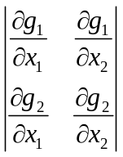 ≡ 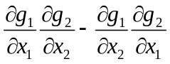 ≠ 0.
J is called the Jacobian of the mapping g₁ and g₂.
  - Then, it can be shown that the random variables Y₁ and Y₂ are jointly continuous with its joint pdf computed by
f_{Y1Y2}(y₁, y₂) = f_{X1X2}(x₁, x₂)×|J(x₁, x₂)|⁻¹ (6.13)
where x₁ = h₁(y₁, y₂) and x₂ = h₂(y₁, y₂).
Proof: see the reference book.

- Example 6.10 ---
Let X₁ and X₂ be jointly continuous random variables with pdf f_{X1X2}. Let Y₁ = X₁ + X₂, Y₂ = X₁ − X₂. Find the joint pdf of Y₁ and Y₂ in terms of f_{X1X2}.
Solution:
  - Let g₁(x₁, x₂) = x₁ + x₂, g₂(x₁, x₂) = x₁ − x₂. Then
J(x₁, x₂) = 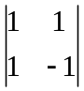 = −2.
  - Also, the equations g₁(x₁, x₂) = x₁ + x₂, g₂(x₁, x₂) = x₁ − x₂ have solutions
x₁ = (y₁ +y₂)/2 and x₂ = (y₁ − y₂)/2.
  - From (7.1), we get the desired pdf for Y₁ and Y₂ to be
f_{Y1Y2}(y₁, y₂) = f_{X1X2}(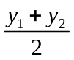, 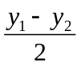).

- Generalization of Theorem 6.1 for more than two random variables ---
See the reference book for the detail.

